**Using template engines with Express**

A ***template engine*** enables you to use static template files in your application. At runtime, the template engine replaces variables in a template file with actual values, and transforms the template into an HTML file sent to the client. This approach makes it easier to design an HTML page.

Some popular template engines that work with Express are [Pug](https://pugjs.org/api/getting-started.html), [Mustache](https://www.npmjs.com/package/mustache), and [EJS](https://www.npmjs.com/package/ejs). The [Express application generator](https://expressjs.com/en/starter/generator.html) uses [Jade](https://www.npmjs.com/package/jade) as its default, but it also supports several others.

To render template files, set the following [application setting properties](https://expressjs.com/en/4x/api.html#app.set), set in app.js in the default app created by the generator:

* views, the directory where the template files are located. Eg: app.set('views', './views'). This defaults to the views directory in the application root directory.
* view engine, the template engine to use. For example, to use the Pug template engine: app.set('view engine', 'pug').

Then install the corresponding template engine npm package; for example to install Pug:

$ npm install pug --save

After the view engine is set, you don’t have to specify the engine or load the template engine module in your app; Express loads the module internally, as shown below (for the above example).

app.set('view engine', 'pug')

Create a Pug template file named index.pug in the views directory, with the following content:

html

head

title= title

body

h1= message

Then create a route to render the index.pug file. If the view engine property is not set, you must specify the extension of the view file. Otherwise, you can omit it.

app.get('/', (req, res) => {

res.render('index', { title: 'Hey', message: 'Hello there!' })

})

When you make a request to the home page, the index.pug file will be rendered as HTML.

Example on jade

views/index.pug

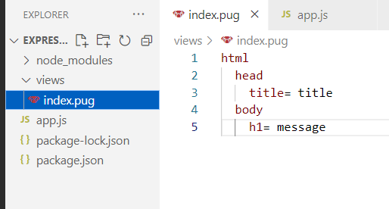

app.js

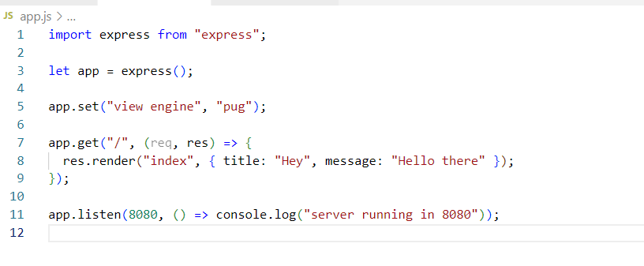

Output:

